
Pupil premium strategy statement

This statement details our school’s use of pupil premium funding to help improve the attainment of our disadvantaged pupils.
It outlines our pupil premium strategy, how we intend to spend the funding in this academic year and the effect that last year’s spending of pupil premium had within our school.
School overview
Detail | Data
School name | St. Martin’s Primary Academy
Number of pupils in school | 103
Proportion (%) of pupil premium eligible pupils | 31 children  29.1%
Academic year/years that our current pupil premium strategy plan covers | 3-year plan from Sept 2024.
Date this statement was published | Sept 2024
Dates on which it will be reviewed | July 2025  July 2026  July 2027
Statement authorised by | Oliver Martindale
Pupil premium lead | Charlotte House
Governor / Trustee lead | Mike Oldham

Detail | Amount
Pupil premium funding allocation this academic year | £81,610
Pupil premium funding carried forward from previous years | £0
Total budget for this academic year | £81,610

Our School Context

St Martin’s Primary School has a unique context within our local area.

Our community is wonderfully diverse, with over 20 different countries represented across the school and 64.1% of our children from a minority ethnic background (compared to 38.9% nationally.)
Our children enormously benefit from the diversity and complexity of their experiences and our whole school vision that everyone belongs here is deeply understood and celebrated among our community.

Historically, the reputation of St. Martin’s has suffered from repeated failures in OFSTED inspections. This has resulted in dwindling pupil numbers overall and a higher percentage of vulnerable learners, particularly PP, EAL and SEN. However, following a journey of rapid improvement and with an investment in quality first teaching, we are now seeing a strong impact in both pupil attainment and family engagement.

A new school nursery, which opened in September 2025, has meant that we are able to support families in receipt of the pupil premium grant in advance of their children being of compulsory school age. As this nursery enters its second year of opening, we are able to see the impact of early investment being represented in our FS2 cohorts.

Our catchment area is the city center and includes a domestic violence refuge, two traveller sites and the Friary Council estate. We proudly welcome families from all three and, as a result, our pupil premium numbers are above average, at 29.1%. By supporting these families, we are often a vital first step in finding early help, supporting traumatic transition, applying for benefits and refugee status and ultimately, enabling a move into permanent and safe housing. We are now utilizing the city center location of our catchment with close links to Salisbury Museum and Wiltshire Creative enhancing our personal development curriculum. An exciting curriculum, with inbuilt opportunities for play, oracy and spirituality, ensures that we meet the needs of all learners, recognizing the importance of their mental health

With only 66.7% of our KS2 pupil premium children starting in EYFS with us, we see the impact of families coming to our school from all over the world mid-year - often with little or no prior experience of school. 40% of our children in receipt of the pupil premium grant have English as a second – or third – language. Immediate assessment and strategically planned learning opportunities ensure rapid catch up. Staff are now able to utilize a strong curriculum, with clear knowledge identified, to fill knowledge gaps and ensure rapid progress. Where historically, this has meant that the attainment of the learners in our school is not representative of their progress, we now have high-quality first teaching and assessment systems in place that recognize the extraordinary progress that our pupils make – from their first words of English to their transition into secondary school.

Our ability to build strong home-school links has historically been impacted by language or cultural barriers, as our relationship with our families has grown stronger, we now are able to offer a wide range of supportive services, including the use of translation apps and digital copies of paperwork in a wide variety of languages. An investment in these relationships has led to more opportunities for our families and a better understanding of how their children can attain highly.

(All national statistics accurate September 2026)

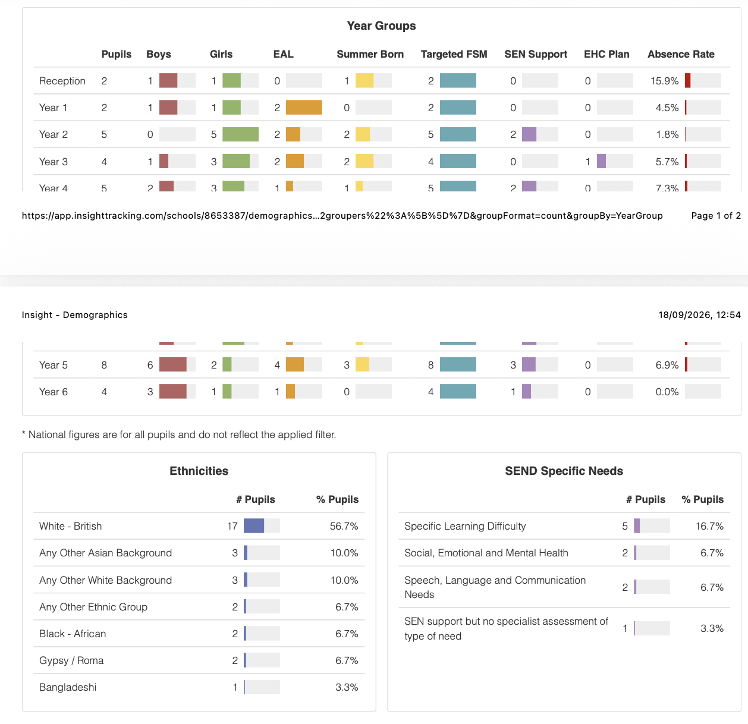
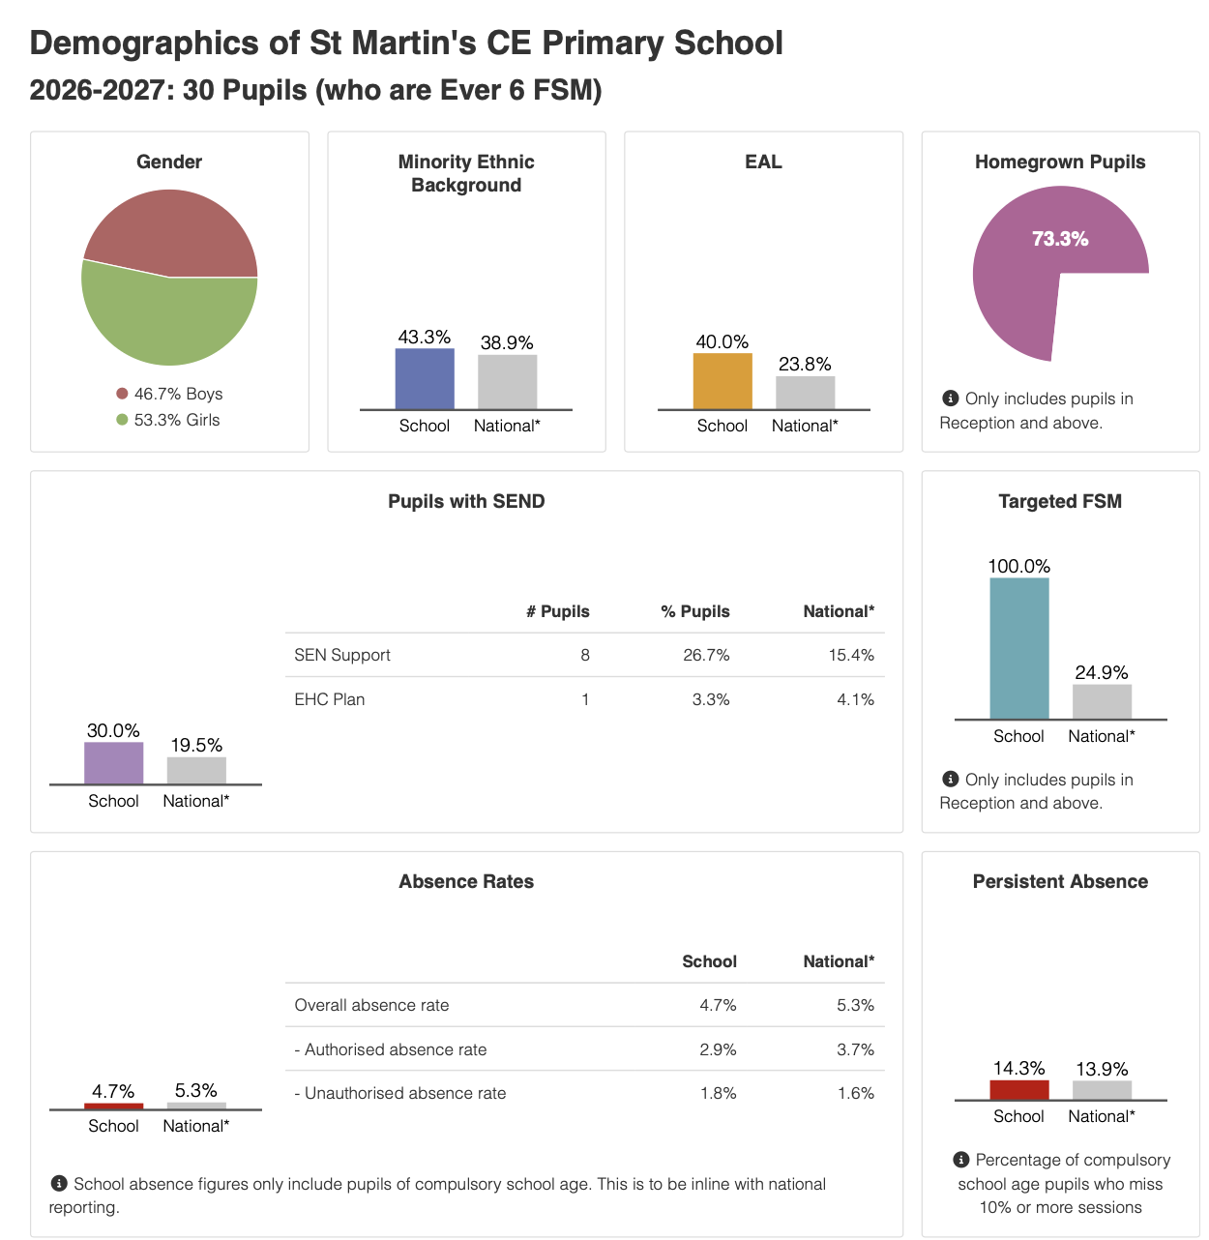

Part A: Pupil premium strategy plan

Challenges

Challenge number | Detail of challenge
1 | The vocabulary, S&L gap evidenced by some disadvantaged pupils across the school resulting in limited verbal skills, and a lack of the everyday contextual underpinning needed to access learning.
2 | Internal assessment and observations indicate lower attainment amongst disadvantaged pupils in one or more core subject areas when compared to their peers.  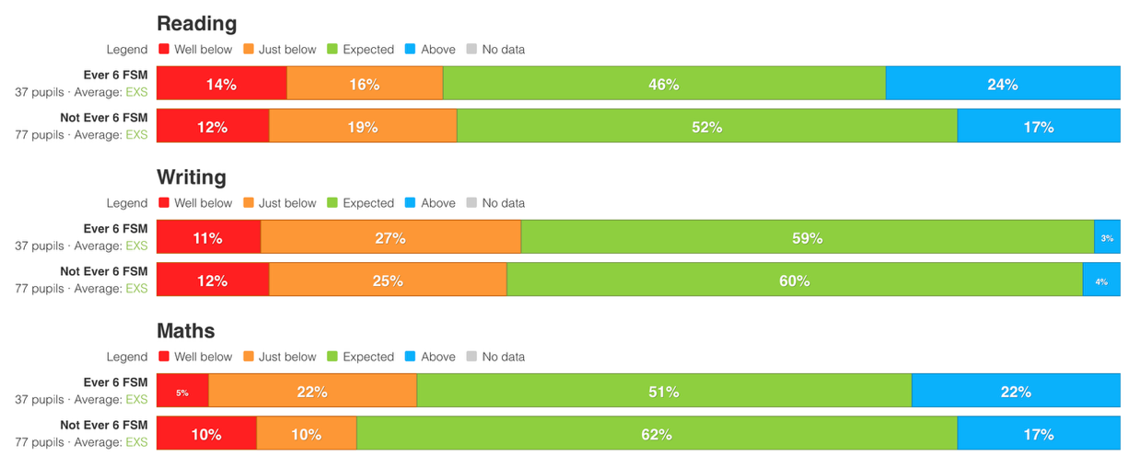
3 | Low and inconsistent attendance and lack of parental engagement for several children eligible for Pupil Premium causes learning sequences to be fractured.  Pupil premium children at St Martin’s school have a persistent absence percentage of 25%, compared to 13.9% nationally.
4 | As part of an ever-changing community, we receive frequent IYT transfers who come with significant gaps in learning and join us at all points in the year.  Only 73% of our pupil premium children are home grown, with many having had multiple housing moves.
5 | Limited wider-life opportunities to inspire and support underprivileged pupils are available in the home and community, which has particularly disadvantaged this group. Insecure housing, poor parental mental health and limited opportunities for work has impacted the opportunities available for that group.
6 | A high percentage of pupils who are eligible for pupil premium are EAL pupils (27.8%). This can indicate significant language barriers – particularly within Tier 2 and Tier 3 vocabulary – which causes understanding gaps while learning and makes vital knowledge difficult to contextualise and retain.

Intended outcomes
This explains the outcomes we are aiming for by the end of our current strategy plan in July 2027 and how we will measure whether they have been achieved.

Intended outcome | Success criteria
Improved oral language skills and vocabulary among disadvantaged pupils. | - Assessments and observations indicate significantly improved confidence with oral language and effective use of subject-specific vocabulary among disadvantaged pupils. This is evident when triangulated with other sources of evidence, including engagement in lessons (demonstrated through use of oracy skills) and ongoing formative assessment.  - NELI language assessments, on start and completion of the program in EYFS, evidence an increase in scores for disadvantaged pupils in identified areas of oral communication.  - Learning walks, book-looks and staff feedback demonstrate oracy and subject-specific vocabulary development in pupils eligible for Pupil Premium because of quality first teaching across the curriculum.  - Whole class communication and oracy strategies, are being taught well and provide direct opportunities for the oral rehearsal and use of strategically planned language.  - Documentation such as Universally Speaking across the school is used to identify gaps in the spoken language of the children. Staff understand well the specific areas of need for their pupil premium children.  - The use of sentence stems and modelled sentences is evident across the school and ensures there is minimal deficit in the spoken language of pupil premium children. This is evident in learning walks, book-looks and staff feedback.
Higher percentage of accelerated progress among disadvantaged pupils so that they close the attainment gap. | - Assessments and observations indicate significantly improved attainment, engagement, and confidence in core subjects among disadvantaged pupils.  - End-of-year reading, Maths, and GPS assessments evidence a higher percentage of disadvantaged pupils making accelerated progress over the period of this statement. 40% of Ever6 children make accelerated progress in two or more subjects.  - End-of-year reading, writing, Maths and GPS assessments evidence a higher percentage of disadvantaged pupils working at the expected standard.75% of Ever6 children meet the expected standard in two or more subjects.
Increased opportunities for cultural capital for disadvantaged pupils to achieve greater equality. | - All KS2 children eligible for PPG are offered (and encouraged to take up) extra-curricular music or sports tuition.  - 100% of children eligible for PPG, for at least one term across the year, attend a suitable, quality extra-curricular club.  - 100% of children eligible for PPG attend Yr. 6 residential school trip.  - 100% of children eligible for PPG take on a position of responsibility such as play leader, school council, librarians, eco lead or learning ambassador.
Improved attendance | - Negligible difference in attendance for disadvantaged children in comparison to their peers.
Exceptional CPD leads to a supported and successful PPG strategy championed by all staff | - PPG leader will engage whole staff body through training, coaching, sharing good practice and using resources strategically.  - PPG children will be additionally tracked as part of assessment schedule and SEND reviews.  - Minutes of Governing Body and committee meetings will demonstrate robust overview of PPG and service premium.  - The school will achieve the stated success criteria in this strategy statement.

Activity in this academic year
This details how we intend to spend our pupil premium (and recovery premium funding)
this academic year to address the challenges listed above.

Teaching (for example, CPD, recruitment and retention)

Budgeted: £41,610

Activity | Evidence that supports this approach | Challenges addressed
The highest quality teaching throughout the school developed through well-conceived and successful continual professional development:  Acadamic year 2026-2027 budgeted cost:  Leadership time used for mentoring  ELS additional resources  - Continue to embed the use of Steplab software to support the model of instructional coaching for staff to develop quality of teaching. Teachers will be trained in carrying out Instructional coaching. Regular coaching then to take place.  - Curate a CPD bank of high- quality resources relating to teaching pedagogy.  - Key messages disseminated to staff regarding best practice.  - Termly CPD given to all staff sharing the relevant priorities for PP children in the classroom and the progress being made towards these outcomes.  - Coaching takes place termly with a focus on quality first teaching strategy and best practice. Use of WALKTHRUs PD pack to structure coaching.  - CPD sessions for all EYFS staff on assessing and developing pupils’ early oral language skills using the Nuffield Early Language Intervention programme (NELI)  - Additional ELS training undertaken by all staff in line with new intervention initiatives.  - Enhanced training for KS2 staff in ELS phonics.  - Use of supportive strategies for recall and knowledge acquisition built into classroom practice. This includes essential knowledge organisers, pre teaching and transferrable, understandable concepts.  - Use of specialist teachers to deliver staff meetings and workshops including EHT who is an NCETM Primary Mastery Specialist and HoS who is a phonics ambassador for our chosen phonics vehicle. | EEF: Good teaching is the most important lever schools have to improve outcomes for disadvantaged pupils.  “The most important factor for attainment and progress is effective teaching. This has been highlighted by the Sutton Trust, whose 2011 report on improving the impact of teachers on pupil achievement in the UK revealed that the effects of high-quality teaching are especially significant for pupils from disadvantaged backgrounds – equivalent to  1.5 years’ worth of learning.”  Sources of evidence on effective delivery of CPD (such as The Teacher Development Trust’s report ‘Developing Great Teaching’ and the Department for Education ‘Standards for teachers’ professional development’) underline the importance of having regular sequential slots to develop teaching. | 1,2, 4
To use metacognition and Oracy as a cornerstone of curriculum provision by:  Acadamic year 2026-2027 budgeted cost:  Staff Oracy materials purchased.  HLTA cover required: £3,600  Visiting speakers.  MindShift reflection journals within UKS2.  - Oracy CPD delivered to staff through Talk21 resources.  - CPD sessions (including Oracy October CPD led by Talk21) for all staff on developing pupils’ oral language skills and vocabulary development.  - Tiered vocabulary used explicitly in all wider curriculum lessons. This includes Tier 1 vocabulary which is taught strategically as part of Drawing Club (EYFS) and pre teaching /flexible grouping within Writing lessons.  - All staff aware of the development of oracy using tools such as Universally Speaking and a intentionally planned vocabulary spine.  - Pupil conferencing conducted on a termly basis focusing on Metacognition and oracy skills.  - Increased focus on presentational talk both within the classroom and in whole school events. | EEF: As well as explicit instruction and modelling, classroom dialogue can be used to develop metacognitive skills. Pupil-to-pupil and pupil teacher talk can help to build knowledge and understanding of cognitive and metacognitive strategies.  EEF: Effective social and emotional learning (SEL) can increase positive pupil behaviour, mental health andwell-being, and academic performance. Public Health England published a report for head teachers and school staff outlining the link between pupil health and wellbeing and attainment.  DFE guidance states that children at risk of falling behind must be identified within the first three weeks of their starting in their Reception year). “One barrier faced by disadvantaged pupils is common across the majority of our schools – poor oral language and communication skills. Our data – based on diagnostic assessment tools to assess pupil’s language skills- has consistently illustrated this gap on school entry.” | 1, 2, 6
A rigorous monitoring schedule ensures we swiftly identify the specific needs of each child so staffing, intervention and timetabling can be amended quickly to meet needs:  Acadamic year 2026-2027 budgeted cost:  Leadership time for PP leader.  Cover for staff to attend SPAM meetings.  - Termly data-driven pupil progress meetings.  - Shift the language staff use. Use the language of present level of attainment to promote sky high aspirations for all.  - Regular shifting present level of attainment meetings (SPAM Intervention impact tracked within these meetings.  - Regular SPAM learning walks to ensure provision is in place and impactful  - IYT children to form a key line of enquiry in these meetings to pinpoint gaps in understanding and implement intervention.  - Behaviour incidents/ patterns of behaviour tracked vis Arbor.  - Service premium children to be closely monitored. | Recent research in England (Kirkup et al 2005) found that the effective use of data can promote better teaching and learning through:  - More effective allocation of staff and resources  - Monitoring the effectiveness of initiatives and strategies  - Evidence-based discussions with the Office for Standards in Education (Ofsted),  - Challenging expectations of staff, pupils, parents, among others  - Transitions and transfers - particularly transitions between key stages within schools  - Identification of pupils’ achievements and setting of targets (Kirkup et al, 2005, p.1)  Durrington Research School: It is essential that any intervention starts with identifying the specific problems for individual students before putting potential solutions in place. | 2, 4
Improving readiness to learn through a smooth transition between FS1 and FS2. Ensuring deficit gap on entry is addressed strategically.  Acadamic year 2026-2027 budgeted cost:  Teacher release time for transition planning  Teacher release time for curriculum development  - Baseline assessment in place on entry to address likely areas of deficit and adapt planning as needed.  - Transition planned carefully with stay and play, nursery visits and an adapted timetable on entry. Close links with feeder nurseries inform this.  - Transition planning for those children who have not attended a nursery with additional transition events.  - Close links to school-based nursery to ensure enhanced provision in place to get children ready for FS2  - Curriculum provides practical opportunities for application of taught early language, including forest fun, healthy movers, story sacks, music therapy.  - Strategic SEN links, including attention autism, early talk boost.  - Parental support in place for areas of need – toilet training, early intervention, sleep support etc.  - Prewriting “ready to write” sessions – eg core strength, muscles, neurological and physiological movements. Squiggle while you wiggle. Development progression “ready to write” with key criteria to support higher this.  - Curriculum enrichment in place to address deficit in experience, eg cooking, gardening, structured sensory opportunity. | EEF: Successful transitions, as identified from case studies in the research, are those with close cross- phase links.  EEF: Children’s early literacy is dependent on their oral language skills. Approaches for teaching early literacy should, therefore, be used in ways that build on approaches that support communication and language, which are fundamental to children’s literacy.  EEF: The approach of promoting physical activity can support children’s executive function.  Engaging children in physical activity regularly and over several weeks may be particularly effective.  Integrating physical activity into tasks that promote other learning opportunities can be effective. | 2, 6

Targeted academic support (for example, tutoring, one-to-one support structured interventions)
Budgeted: £20,000

Activity | Evidence that supports this approach | Challenge number(s) addressed
Regular targeted reading intervention for lowest 20% of readers, meeting the individual needs of the child and giving them the opportunity to read with and to an adult on a regular basis:  Acadamic year 2026-2027 budgeted cost:  Funding for two days of Reading specialist  Key texts (Books)  TA cover required  - All PPG children working below the expected standard in reading to undergo a YARC and other diagnostic reading tests within the first two weeks to pinpoint specific area of need.  - PPG children daily readers.  - Academic mentor, who is a reading specialist, employed to work two days a week.  - PPG children provided with individual key texts and opportunity to read ahead.  - PPG children targeted to achieve the school reading challenge in school.  - CPD delivered every term regarding reading lessons.  - All children to remain on the school reading scheme to ensure tight tracking of this transition year group.  - High interest/low threshold reading scheme books in place and carefully targeted through 1:1 and small group reading. | EEF states that:  Small group tuition has an average impact of four months’ additional progress over the course of a year  Small group tuition is most likely to be effective if it is targeted at pupils’ specific needs. Diagnostic assessment can be used to assess the best way to target support. | 1, 2
Continue to embed ELS assessment system across EYFS/KS1 and for those struggling readers in Yr. 3/4 to ensure that any children who are falling behind are swiftly identified and an intervention put in place:  Acadamic year 2026-2027 budgeted cost:  ELS training purchased.£300  Whole school reading scheme books purchased.  Low threshold/high interest books ordered  - Rigorous external phonics CPD given to lead in EYFS and KS1. This CPD to continue at regular intervals throughout the academic year.  - All PP children to undertake an ELS diagnostic test in September.  - ELS invited in for a yearly audit to evaluate provision | From the New Reading Framework 2021: “Children at risk of reading failure Pupils who fail to learn to read early on start to dislike reading. The guidance emphasises that pupils need to keep up with their peers rather than be helped to catch up later.” | 1, 2
Establish small group Maths, and English interventions for disadvantaged pupils falling behind age-related expectations:  Acadamic year 2026-2027 budgeted cost:  TA time required to cover staff implementing intervention.  ELS resources  - Class teachers provide targeted pre teaching and over learning to a small group of children during registration.  - Class teachers given dedicated time to curate in class interventions.  - Targeted diagnostic testing in place within the first 3 weeks of Autumn 1.  - Early assessment within the first three weeks of EYFS to quickly identify speech and language difficulties so that we can quickly implement NELI intervention.  - Daily transcription and fine motor in EYFS and KS1 with targeted transcription intervention within KS2. | EEF toolkits identifies that Evidence indicates that one to one tuition can be effective, delivering approximately five additional months’ progress on average. Short, regular sessions (about 30 minutes, three–five times a week) over a set period of time (6–12 weeks) appear to result in optimum impact.  Small-group support is more likely to be effective when: a. children with the greatest needs are supported by the most experienced staff; training, support and resources are provided for staff using targeted activities.  Considering how classroom teachers and teaching assistants can provide targeted academic support, including how to link structured one-to- one or small group intervention to classroom teaching, is likely to be a key component of an effective Pupil Premium strategy.”  OFSTED identified that the best practice, when using the PPG budget, is done through schools allocating their best teachers to teach intervention groups to improve mathematics and English. | 1,2 and 4
Delivery of NELI programme for EYFS children and targeted group of Yr. One children who have EAL:  Acadamic year 2026-2027 budgeted cost:  Neli resource pack purchased  Cover for EYFS TAs 2 hour pw for 20 wks | Compared to children who did not receive NELI, children on the programme progressed on average an equivalent of three additional months in language skills and two additional months in early word reading. | 1, 2
 | Children with English as an additional language, a growing cohort within the school, on the NELI programme made the equivalent of three additional months’ progress in language skills.

Wider strategies (for example, related to attendance, behaviour, wellbeing)
Budgeted: £20,000

Activity | Evidence that supports this approach | Challenge number(s) addressed
Encourage reading for pleasure by:  Acadamic year 2026-2027 budgeted cost:  Time out of class for DHT to support library visit.  Class and school library books regularly purchased.  PP book box subscription purchased for PP children.  PP book box materials purchased. | EEF: On average, disadvantaged children are less likely to own a book of their own and read at home with family members, and for these reasons may not acquire the necessary skills for reading and understanding challenging texts.  Centre for Literacy in Primary Education (CLPE): Research shows that if you are  A literate child who reads for pleasure then this has more impact on your future life chances than any other factor. Encouraging reading for pleasure is a social justice issue. | 1, 2, 5
- Increasing the number and quality of decodable books for older children.
- Lunchtime reading opportunities in place so that children with few books in the home can access resources necessary.
- Book in a box opportunity to ensure that children have resources necessary in the home.
- All PP children to have a library card and termly visit to Salisbury library. DHT to monitor and support return of books to ensure no financial implication.
- Phonics buddies from KS1 and KS2 to support reading for pleasure. In place
- Ensure rich texts (as part of reading for pleasure and the reading curriculum) represent experiences of PP children (including, for example, use of the foodbank etc.) Reading spine in place
- Support sessions (including videos to access at home) to support parents reading with children – decrease expectation on phonics etc and prioritise enjoyment and reading for pleasure.
- Library and library system now in place
To provide disadvantaged children with free access to experiences that enhance their wider experiences.  Acadamic year 2026-2027 budgeted cost:  PP uniform subsidised  PP Sports clubs subsidised.  PP trips subsidised.  Home learning club- TA additional hours £3000 TA overtime. TA hourly rate £13.47  Release time to organise and facilitate links to local businesses.  - A whole school understanding that cultural capital doesn’t just mean access to a wide range of experiences, it is also the equity created by the ability to communicate around and apply knowledge from their experiences.  - Subsidized after school clubs, trips and visits, swimming lessons.  - PP engagement with local businesses to wider understanding of local opportunity and broaden horizons, including the Cathedral, Museum.  - Close links to local secondary schools, including access to resources, trained staff and opportunities.  - HLTA home learning club x 2 weekly.  - Dedicated PPG Forest School sessions.  - Oral composition planning lesson to be timetabled into the writing sequence including immersion in the historical, social context of the key text.  - All PP children take on areas of responsibility across the school, including worship council etc.  - Higher attaining pupil premium learners in KS2 will be connected with a mentor from the closely geographically located independent school. | EEF: Only 2% of children eligible for FSM, compared to 11% of those not eligible for FSM, have participated in a private lesson for extracurricular activities, such as a piano lesson [during the period of the pandemic]  Only 8% of children eligible for FSM, compared to 16% of those not eligible, have participated in a group extra- curricular lesson, for example a drama class [during lockdown].  National Curriculum and OFSTED handbook (2019): Those parents equipped with cultural capital are able to drill their children in the cultural forms that predispose them to perform well in the educational system. It is the essential knowledge that pupils need to be educated citizens, introducing them to the best that has been thought and said and helping to engender  an appreciation of human creativity and achievement. | 1, 3, 5
To empower children with an understanding of their strengths and areas of development:  Acadamic year 2026-2027 budgeted cost:  Happy Self journals purchased for UKS2.  Mindfulness resources regularly updated e.g., chess, yoga.  HLTA cover required to cover target setting meetings  - Metacognition Happy Self journals introduced within UKS2.  - UKS2 PP children buddied up with pupils from the local secondary school for peer mentoring.  - Journalling introduced into KS1 through early morning work.  - SEL to form the bedrock for adapted PSHE curriculum.  - The ELSA will spend 50% of her timetable supporting disadvantaged pupils with their SEL.  - Regular target setting meetings between class teacher and children- these will be visible within the classroom.  - Reflection a cornerstone in all subjects- reflection shapes. | EEF: As well as explicit instruction and modelling, classroom dialogue can be used to develop metacognitive skills.  Pupil-to-pupil and pupil teacher talk can help to build knowledge and understanding of cognitive and metacognitive strategies. | 1, 2, 6
Implementing strategies to ensure regular attendance:  Acadamic year 2026-2027 budgeted cost:  PP Sports clubs subsidized  Drawing therapist for individual children (part subsidized by PBS)  - Working closely with staff responsible for attendance.  - Breakfast provided for Ever6 children.  - Dedicated staff time focusing on attendance/ supporting children to improve attendance.  - Providing funded places at before school clubs.  - Facilitating parent engagement groups to ensure regular attendance.  - Allocate regular set afternoons for our SENCO to liaise with struggling families on a weekly basis.  - Termly open classroom opportunities to invite parents into classrooms. These should be wider-curriculum themed to decrease parental anxiety around English and Maths.  - Increased programme of parental workshops at times convenient for our families.  - Increased cycle of parent voice to identify barriers to attendance.  - Play therapy and ELSA to engage children who are reluctant attenders due to anxiety or prior life ACEs. | DfE (2020): Central to raising standards in education and all pupils can fill their potential is an assumption that is so widely understood that it is insufficiently stated: pupils need to attend school regularly to benefit from their education  Children with poor attendance tend to achieve less in both primary and secondary school.. EEF:  Communication should be two-way: consulting with parents about how they canbe involved is likely to be valuable and increase the effectiveness of home- school relationships. | 3

Additional activity:

Our pupil premium strategy will be supplemented by additional activity that is not being funded by pupil premium or recovery premium. This will include:

- Enhancing our practice around curriculum design ensuring all subjects demonstrating cohesive and coherent steps in disciplinary and substantive knowledge.

- Utilising Trust- wide CPD and working collaboratively with trust hubs and links with ‘best practice’ schools in our local area.

- Continuing to utilise support from our local Mental Health Support Team, particularly for small group provision, with focus children included.

- Offering a wide range of high-quality extracurricular days and events to boost wellbeing, behaviour, attendance, and aspiration. Particular focus to be on events and extracurricular days to enhance close links with families and the local community.

- Carefully planned enrichment opportunities, with a combination of rich experiences and practical life skills to ensure all disparity between children in receipt of PP and children who are not.

- Continued close links with Godolphin and Bishop Wordsworth schools to support children with 1:1 mentorship and additional reading opportunities. Disadvantaged pupils and their families are supported to participate.

Part B: Review of outcomes in the previous academic year

Pupil premium strategy outcomes

This details the impact that our pupil premium activity had on pupils in the 2025 to 2026 academic year.

Teaching and targeted academic support

- Steplab coaching program in place to ensure quality first teaching across the school.
- Termly SPAM meetings ensure all staff are aware of the needs of children in receipt of the pupil premium grant and are addressing them through quality first teaching. PP lead linked closely with SENCO/interventions lead to ensure provision in place as needed.
- Supportive strategies for recall and knowledge acquisition built into classroom practice and evidenced in learning walks and book looks. This includes essential knowledge organisers, pre teaching and transferrable, understandable concepts.
- Pupil conferencing introduced in Y1 and Y4 with significant progress in these year groups.

Statutory assessments

MTC
7/8 children scored 25 or 24

EYFSP
- 50% of pp children achieved GLOD
- Significant progress for the child who did not achieve GLOD, who spoke only Arabic at the start of the academic year. (See pp tracker for specific interventions in place for this child academic year 2026-2027.)

- EYFS Early language provision and use of NELI intervention showed rapid progress for 1 child who was in the 16th percentile when assessed and who then achieved GLD.

- Curriculum enrichment addressed deficit in experience for 2 particularly vulnerable children with structured sensory play and real-world opportunities tailored to their individual needs.

- All pp children achieved ELG in all prime areas

Phonics screening
3/5 children passed

Attainment in Summer 2026 (excluding 2 children who were assessed against the EYFSP)

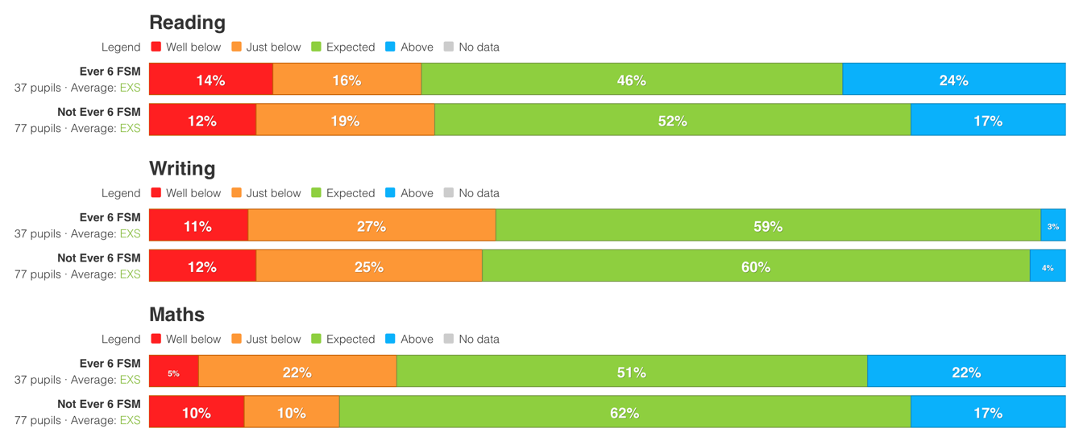

Progress from Autumn 2025-2026 to Summer 2025-2026 (to include progress data for pupils who were not present in Summer 2024-2025)

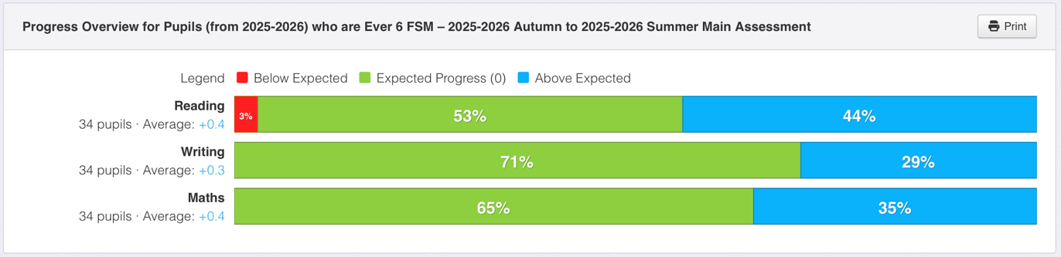

Wider strategies (for example, related to attendance, behaviour, wellbeing)
- 10/31 children from 3 families, with rigorous pastoral support in place. Only 4/31 of the pupil premium children had attendance below 91% Designated SLT member responsible for attendance has ensured that targeted support is in place for persistent absentees.
- Access to in class breakfast and snack boxes closely monitored through My Concern records and families supported with 14 food bank referrals through the academic year (compared to 5 the year before)
- Funded places at breakfast and after school provision offered to all pp families, with reminders throughout the year. Uptake by 3 families (7 children) who would not already have been accessing that provision.
- Reading spine and designated class worship texts in place and represent experiences from a diverse range of families and financial situations, including food insecurity, families who are refugees. Pupil voice indicates a high engagement with class worship texts and an understanding that the stories featured help us to understand and appreciate the experiences of our peers.
- Pupil voice indicates support is being accessed as needed. (For example Y5 pupil: It was scary at first. People help me here and check in and talk to Mum if not. Have time with [ELSA teacher] if I needs it.)
- Subsidised trips ensure all children with pupil premium had trips paid for. Extra-curricular clubs subsidized, including access by 9 children to gymnastics lessons.
- ELSA and MHST provision in place for 8 children – all children who required this, with all children in receipt of the pp grant being evaluated as a priority.
- Decrease of incidents of significant behaviour recorded on Arbor with 75% of incidents involving 6 high profile children with significant additional needs beyond their receipt of the pp grant, including two children with EHCP and a further two with additional SEMH needs. All incidents were supported with 1:1 ELSA and adapted SEN support as needed. 78% of incidents happened in the Autumn term, showing that provision did support a decrease in significant behaviour.

